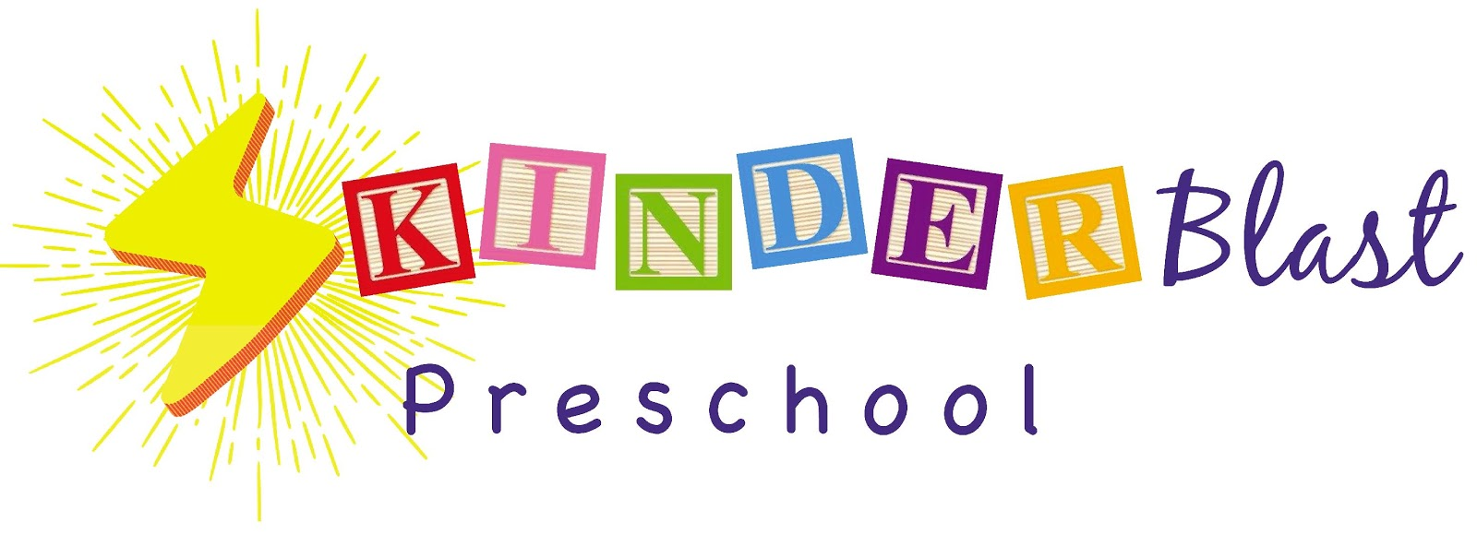
2023/24 School Calendar
We will be closed:
Staff Dev. Day Jul. 31st
Labor Day Sep. 4th
Staff Dev. Day Oct. 6th
Indigenous Peoples Day Oct. 9th
Veterans Day observed Nov. 10th
Thanksgiving Nov. 23rd and 24th
Winter Break Dec. 25th – Jan. 5th
Staff Dev. Day Jan. 8th
Martin Luther King Day Jan. 15th
Presidents Day Feb. 19th
Staff Dev. Day March 8th
Spring Break April 8th – 12th
Community Field Trip May 17th
Memorial Day May 27th
Graduation (Half Day) June 21st
Summer Break June 24th – July 5th

